**Design a Parking Lot**

**Overview:**

1. Align your thoughts with interviewer and tell him what do you know about parking lot (either you know about system or not aware about system then ask interviewer about that)
2. Ask what type of Application. Either web based, where data will be stored or system application where you can take input from cli

**Gathering Requirements**: (Think from outside to inside of parking lot)

Think about what constitutes a parking lot.

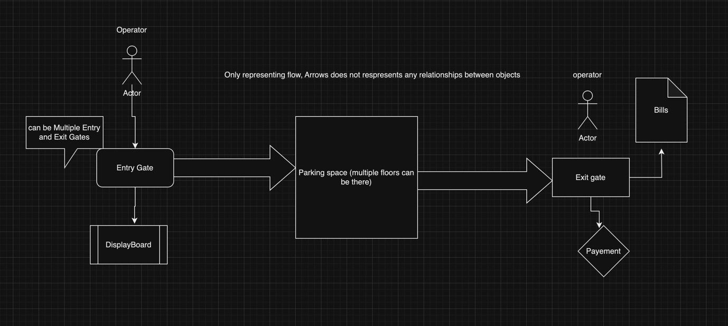

Questions can be:

1. Will there be one floor or multiple floor parking?
2. Each floor has multiple spots.
3. Can we park a set of vehicles at particular spot?
4. Does it support multiple gates?
5. Will there be any display board for showing available parking spaces?
6. Will it be operated by some person?
7. Do we support multiple type of vehicles?
8. At entry a ticket is given by operator.
9. Operator can mark a slot as full.
10. When a ticket is issued a spot is assigned.
11. How we will calculate amount, it will be based on time or based on vehicle and time or only vehicle?
12. Do we support multiple payment methods?
13. Do we support partial payments?

**Class Diagram:**

1. Visualize nouns.
2. Visualize both entity and user journey and find out all the classes.

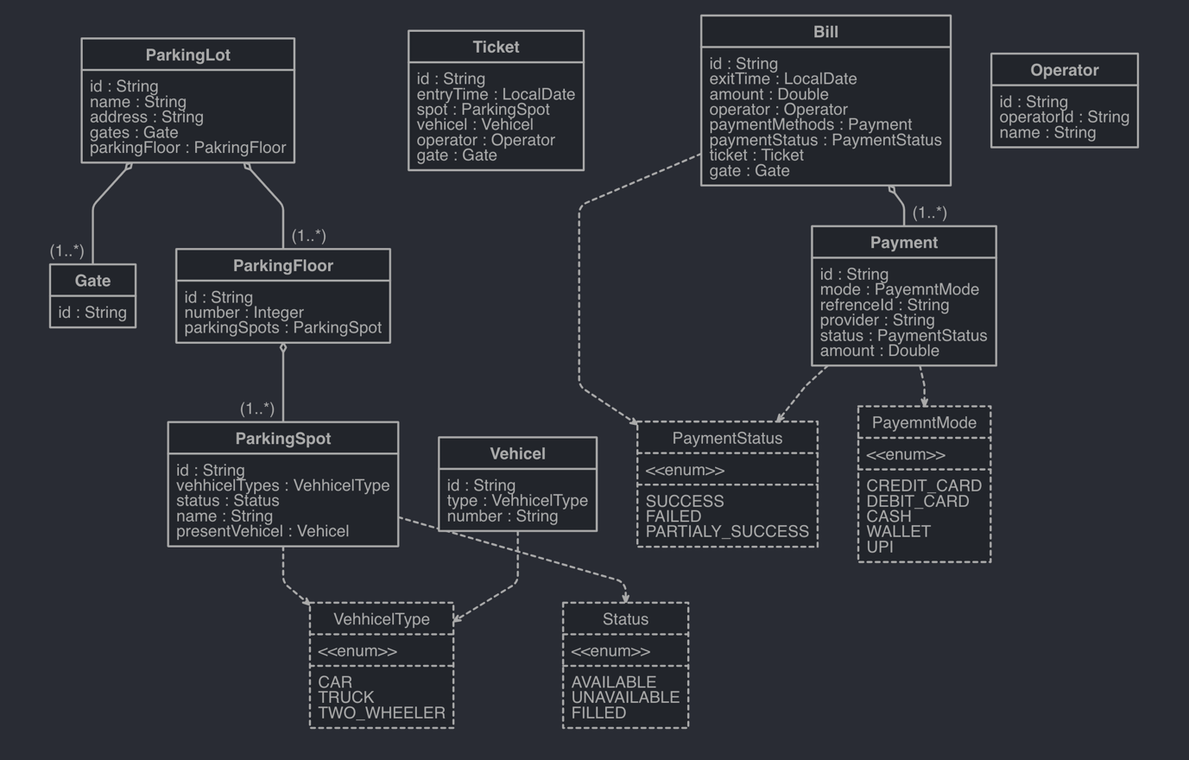

**Design Pattern can be used:**

*Strategy Design Pattern:*

1. Assign spot Strategy
2. Fee calculation Strategy

*Adapter*:

1. For third party payment provider.

************************************END************************************

Do coding part